CREATE A CLOUD OBJECT STORAGE SERVICE

# IBM-Project-27598-1660060762

# Team Leader : Dheepakraj P

# Team Member : Dhachayani K

# Team Member : Divi Sushma

# Team Member : Srinivasa Reddy D

STEP1:

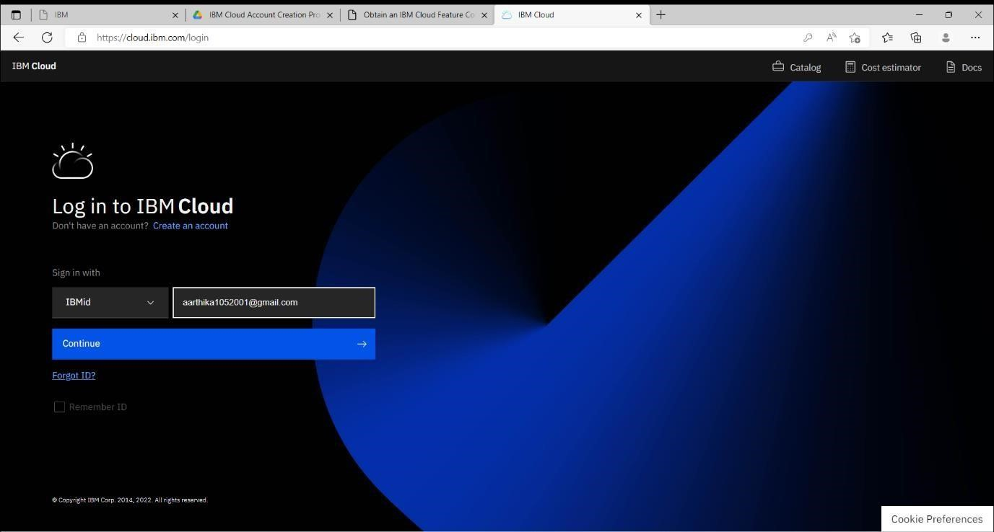

STEP2:

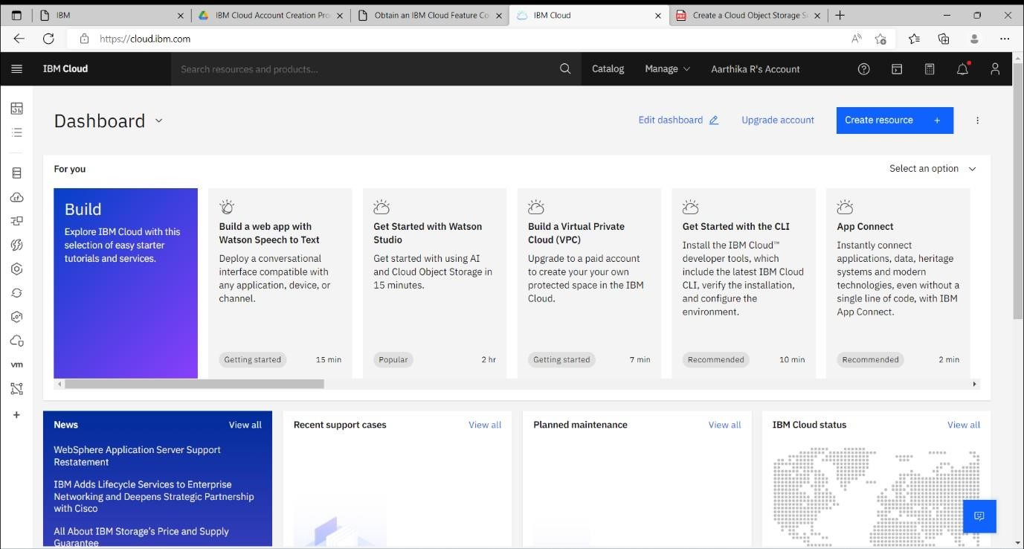

STEP3:

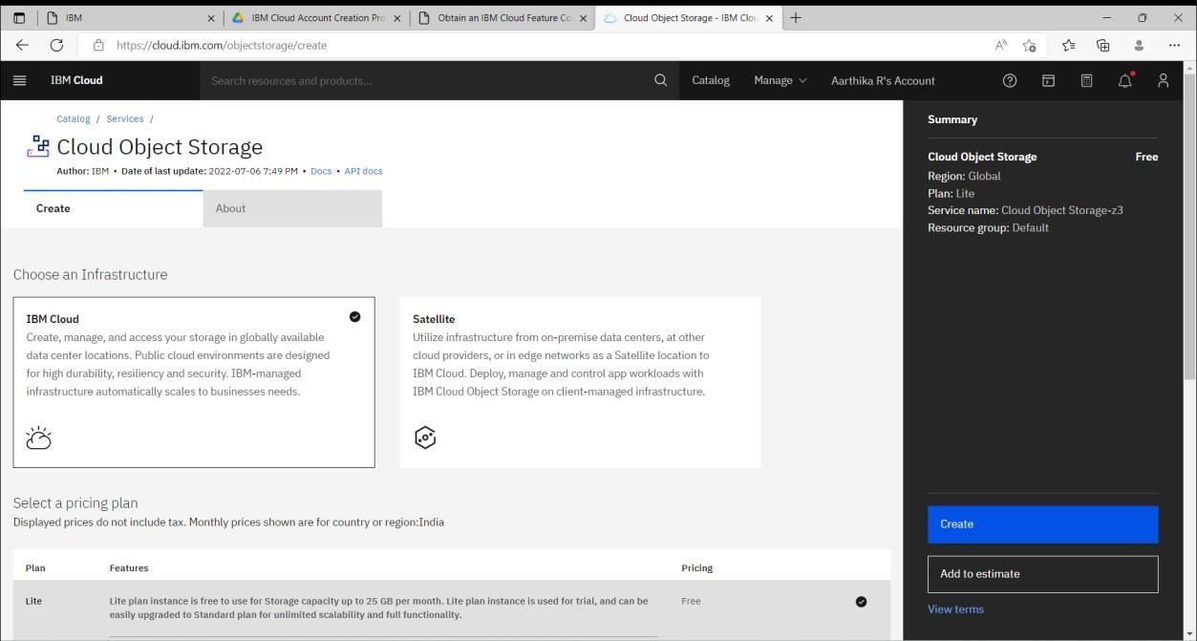

STEP4:

5

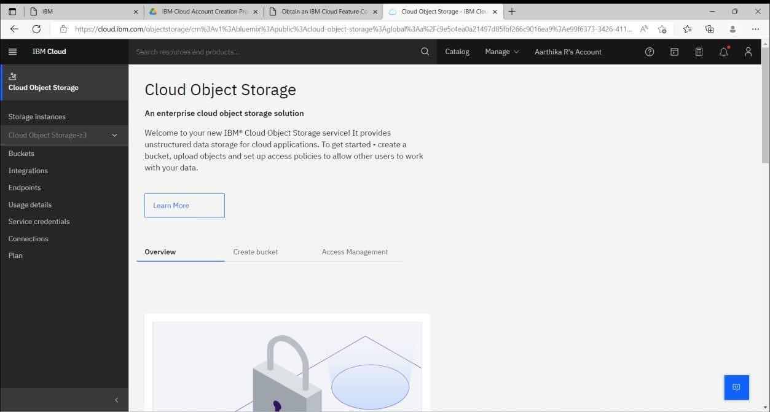

STEP5:

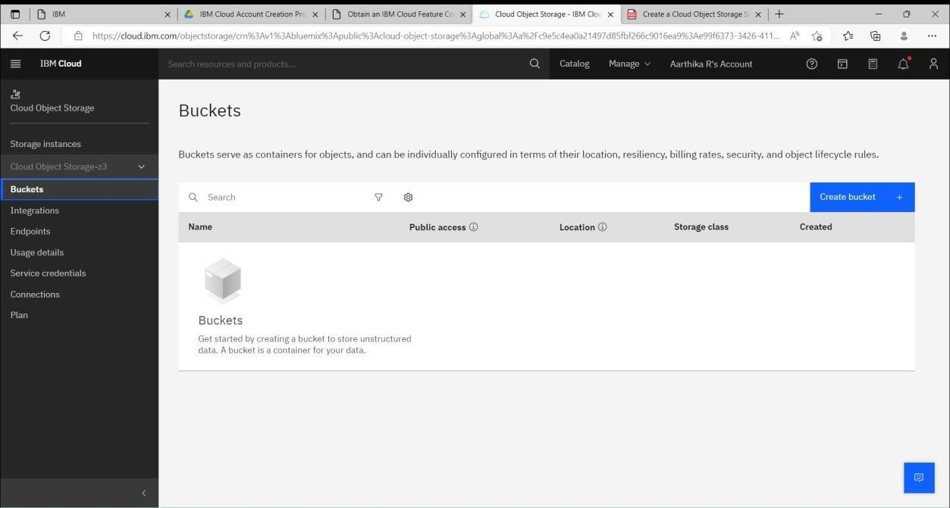

STEP6:

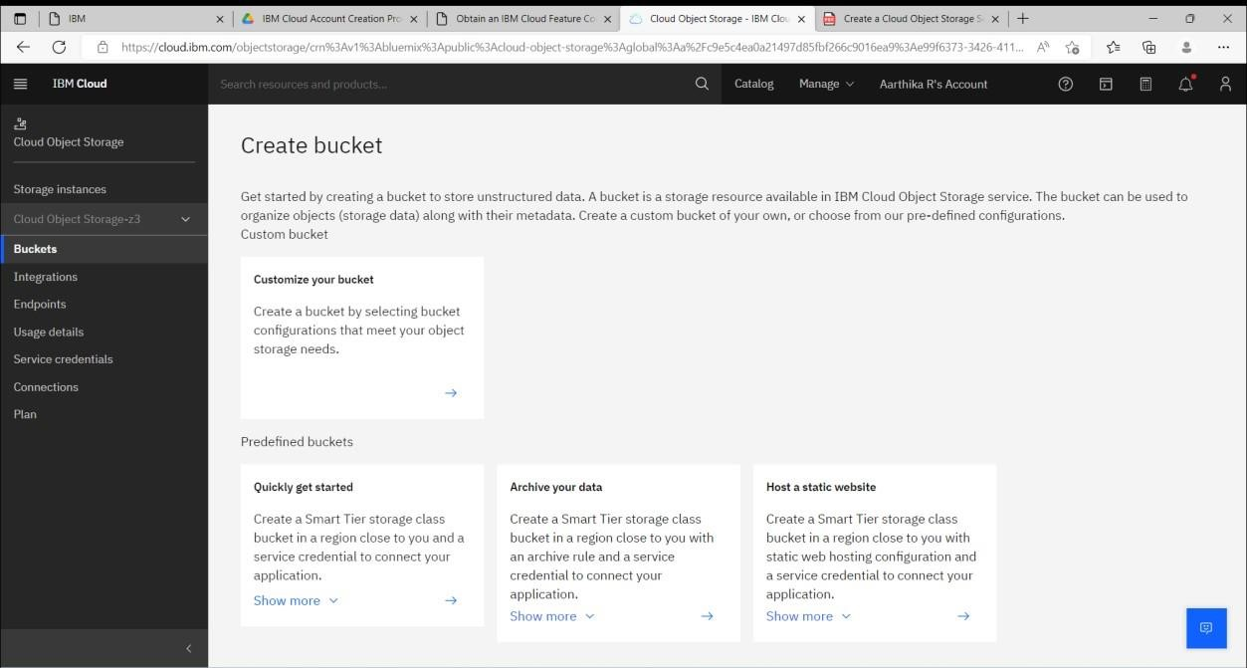

STEP7:

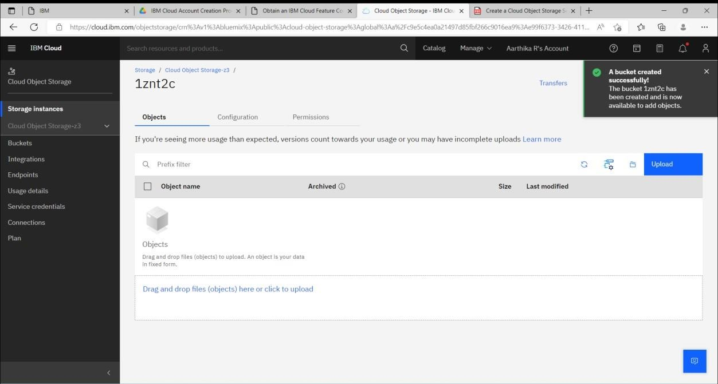

STEP8:

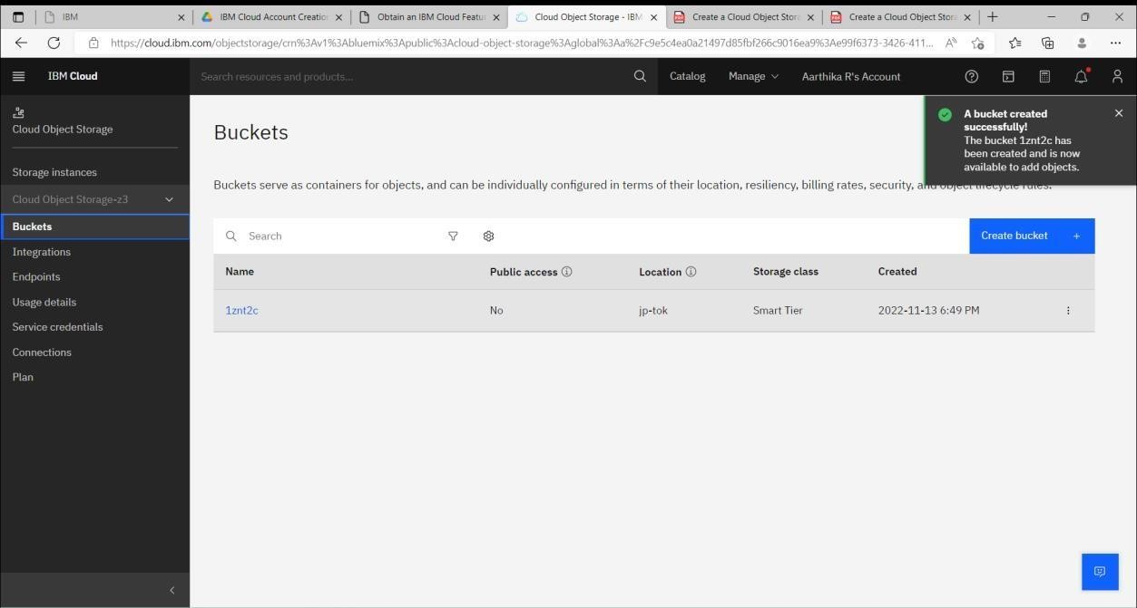

STEP9:

